Causes of Mongol Expansion

The Mongol empire was one of the largest empires of all time. Before the empire reached its height, the Mongols were a series of fragmented tribes. These tribes regularly fought amongst themselves. It was not until a skilled warrior and son of a chief defeated a neighboring tribe that the Mongol empire begun its existence. This skilled warriors name was Genghis Khan and his policies allowed the Mongol empire to grow to its height. After conquering a community, Genghis Khan forbade looting, raping, and murdering the conquered people. Genghis Khan believed that if people submitted peacefully and paid taxes they should be left to live their lives in peace. Furthermore, Genghis Khan believed that the spoils won from a conquest should be shared with the entire Mongol population, not just the aristocrats. This was popular among the common people in the empire and as a result, Genghis Khan gained popularity and support.
Geographic factors meant that the Mongols could not just stay in the territory where they came from. The Mongols came from a Steppe geographic region, characterized by its short grass. This short grass was not ideal for farming or raising livestock. In order to get needed resources the Mongols were constantly on the move, raiding settled communities to get food and supplies they needed for survival.

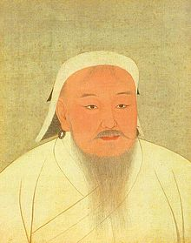
Effects of Mongol Invasions

After the Mongols gained power over various kingdoms, they were able to establish a unified territory across Eurasia. Contrary to popular belief, the Mongols did not kill everyone who was in their way. In fact, as long as local leaders paid taxes to the Mongol Dynasty, local leaders were allowed to remain in power. In return for their taxes, the Mongols provided the people in their territory with protection from outside invaders. Safety in the region led to a time called the Pax Mongolian during which time the Silk Road trade reached its height. With the Silk Road being safe and well-traveled, many Europeans gained knowledge of Asian advances, especially those of the Chinese. While the Chinese advances flourished in this time, the Mongols made no advances themselves. Cultural growth was actually stifled by the Mongols due to a belief in tribal ways.
The Mongols believed in religious toleration. They understood that they had a huge variety of people throughout their territory with differing beliefs and if they wanted to stay in power, they could not force their beliefs on everyone. However, through the vast Mongol territory, and the safe trade routes they established, cultural diffusion occurred as cultures and ideas were spread.

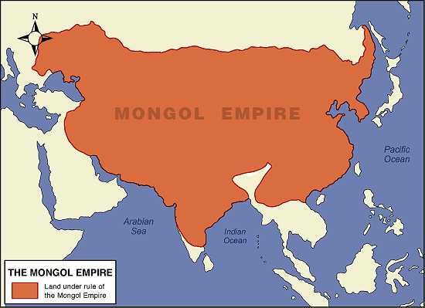

Mongol Invasions of Russia
As the Mongols expanded their empire, Russia came under Mongol control. Even though Russian territory was controlled by the Mongols, local Russian rulers were allowed to stay in power. The Mongols demanded that the Russians paid a tax to them in return for protection and the autonomy of ruling for the Russians. In order to collect these taxes, Russian bureaucrats placed heavy taxes on the peasant class. Russia was in a system of feudalism and these heavy taxes took a large toll on the peasants. Serfdom expanded during this time period as the peasant class was tied to the aristocrats land in order to pay the taxes they owed.
The system of feudalism in Russia was another reason why the Mongols were able to take control of it. With many different kingdoms, with many different rulers Russia was not politically unified. With the Russian people separated from each other through feudalism, their cultural development remained stagnant. As Russian cultural was halted, the rest of Europe was culturally growing, thanks to the revived trade made possible by the Pax Mongolia. The lack of unity also made it near impossible for the Russians to overthrow the Mongols. It was not until Tsar Ivan (Ivan the Great) came into power and brought the Russian people together that the Mongols were overthrown after 200 years of power in Russia.
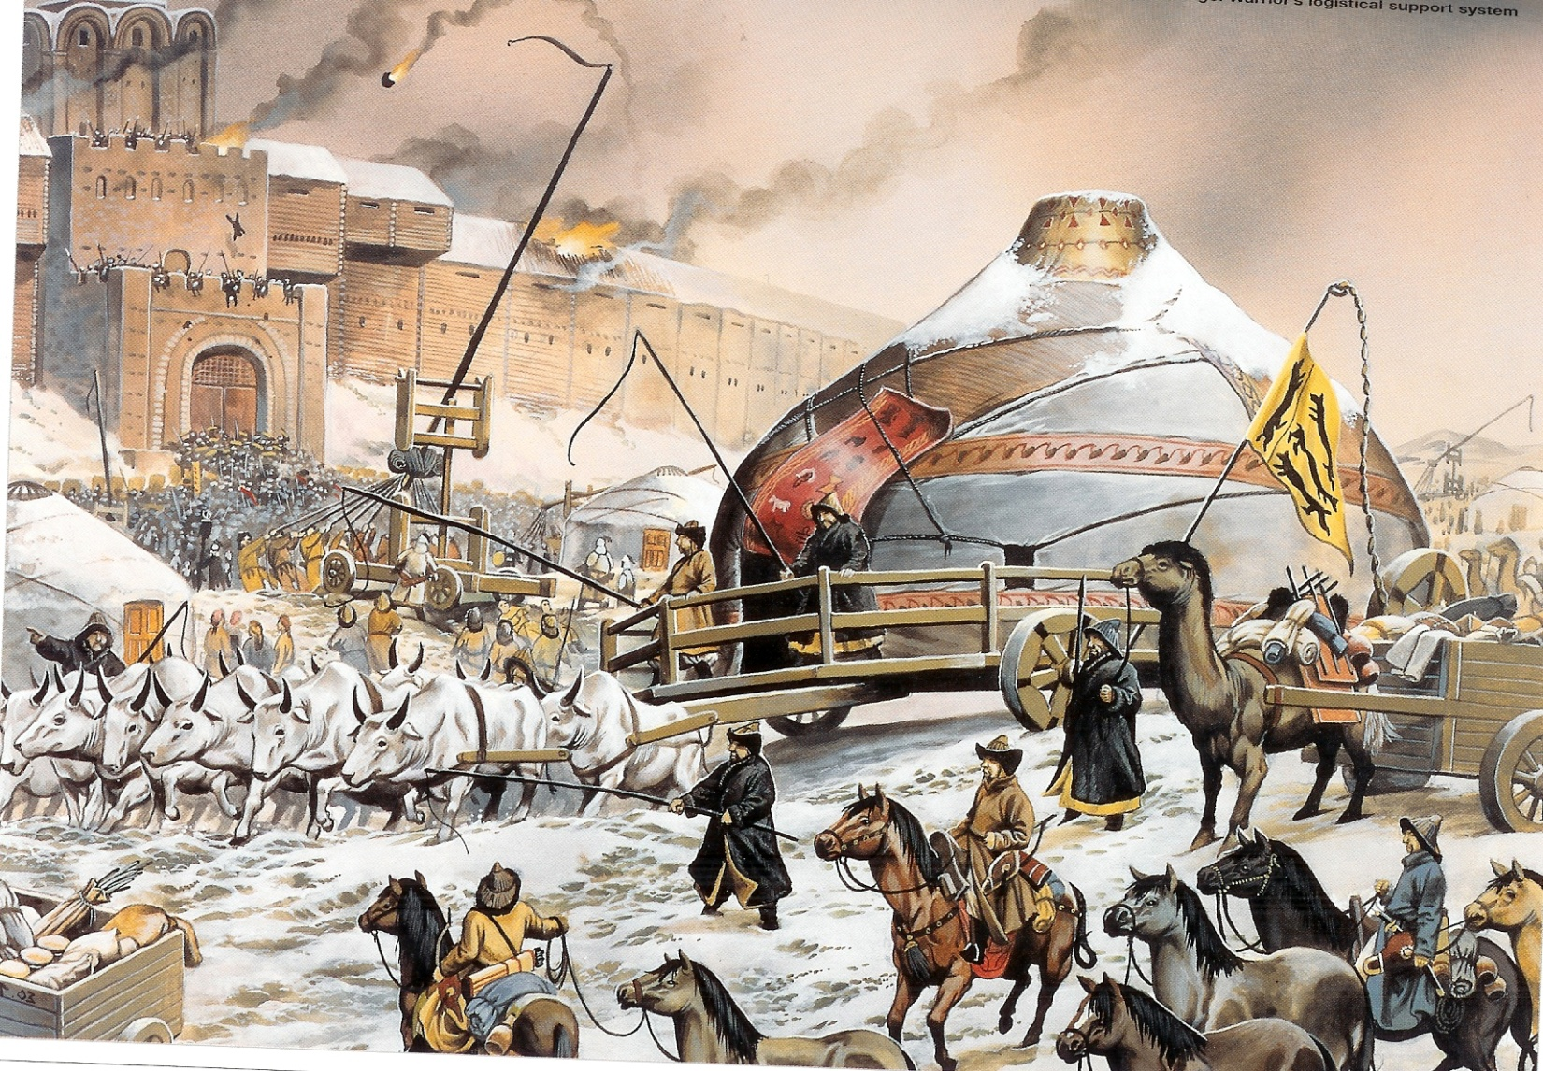
Mongol Invasions of China
Geographically, China was one of the closest dynasties to the growing the Mongol empire. Because of this close vicinity, it was not long until the Mongols set their sights on controlling China. In 1215, the Mongols were successful in capturing Beijing and it was not long that in 1279 they overthrew the Song Dynasty. For this first time in China’s existence, they were being ruled by a foreign power.
The foreign Mongols changed many of the rules and customs that the Chinese had in place. First, they ended the civil service exams and the bureaucracy was no longer staffed with those most qualified to work. Instead, Mongols entered the bureaucracy. Not only were the Chinese being politically ruled by foreigners, but the inner workings of the government were also staffed by Mongols and not Chinese.
Even though the Mongols were running the country as a whole, they still realized that in order to maintain power they would have to keep the Chinese people happy. In order to achieve this, the Mongols made different laws for the Chinese, which were similar to the laws they were used to before the Mongols invaded. The Chinese people were also separated from the Mongol population living in China. This separation allowed the Chinese to maintain their unique cultural identity separate from the Mongols.
At this time, China was a thriving center for trade. Beijing was connected to the European city of Vienna via horse relay stations. The Silk Road trade also reached its height under the Mongol rule. However, the Mongols were not directly involved in trade. They did not make new inventions that would have attracted people to the empire. Instead, the Mongols encouraged those in their empire to experiment with new ideas. They also welcomed foreigners into their court to see the great achievements that were being invented by the people under their rule. Furthermore, these foreigners brought precious items from their homeland to trade with the Mongols, creating more wealth within the Mongol empire. The Mongols openness to foreigners caused overland and maritime trade to flourish.

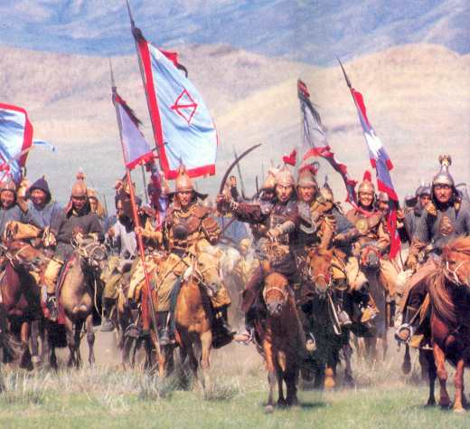
Mongol Invasion of Islamic World
After conquering much of Asia, the Mongols set their sights on the Middle East. During this time, the Middle East, and parts of Africa and Asia Minor were politically unified by the Muslim empire under the rule of the Abbasid Caliphate. This political unity ended in 1258 when the Mongols marched into the Islamic empire and defeated the Abbasids. The Mongols treated the people they conquered very well; they were not murdered or made slaves as in the past. The Mongols allowed the local leaders to continue their rule as long as order was maintained and taxes were collected. The Mongols even employed local bureaucrats to collect these taxes, which was very popular among the people since they were able to still have good jobs.
After spending many years among the Muslim people, the Mongols began to appreciate their culture. By 1295, many Mongols converted to Islam. Just like when Islam spread to Africa and Asia, Mongol culture mixed with Muslim traditions.
The Mongols were not completely successful throughout the entire Muslim World. In 1260 the Mongols marched into Egypt to try and conquer the Mamluk people. The Mamluks fought hard and defeated the Mongols. They were able to keep their political and cultural identity without having to pay the Mongols any taxes. This defeat was the first and only defeat and the Mongols in the Islamic World.
The Mongols had more trouble trying to conquer India than the rest of the Muslim world. In Northern India the Dehli Sultanate was in power. The Dehli Sultanate was able to hold off repeat Muslim invasions for many years. However, by 1398, the Mongol army proved to be too powerful and they were able to successfully invade India. The Mongol warlord Timur ruled India for the Mongol empire for a short time before the collapse of the Mongols.

